**SL - Practical - 2**

**Name: Rishabh Jain**

**Branch & Sem: CSE - IV**

**Sec: A**

**Roll no.:54**

**AIM:**

1)Conditional Statements  
WAP to output Grade “C” if entered marks are between 50-65, “B” for 66-80 and “A” for 80-90 and “A+” for above 90.

2) Arrays and loops  
WAP to create an array(read elements entered by user) which should allow only unique values, if there are duplicates, then keep the first occurrence and remove the duplicates.  
  
3) String  
WAP to count the number of vowels in a paragraph.

4) Functions  
Write a function to reverse a given number. Use this function to check whether a number is a palindrome or not.

Code:

Q1)

<!DOCTYPE html>

<html lang="en">

<head>

    <meta charset="UTF-8">

    <meta http-equiv="X-UA-Compatible" content="IE=edge">

    <meta name="viewport" content="width=device-width, initial-scale=1.0">

    <title>Document</title>

</head>

<body>

    <script>

        mark=parseInt(prompt("Enter your marks"))

        Evaluate(mark);

        function Evaluate(mark)

        {

        if(mark>90)

        {

            document.writeln("Congratulations you passed with fyling colors with A+ grade")

        }

        else if(mark>=80 && mark<=90)

        {

            document.writeln("Congratulations you passed with A grade")

        }

        else if(mark>=66 && mark<80)

        {

            document.writeln("Congratulations you passed with B grade")

        }

        else if(mark>=50 && mark<=65)

        {

            document.writeln("Congratulations you passed with d grade")

        }

        else

        {

            document.writeln("You failed!!!")

        }

        }

        </script>

</body>

</html>

Output: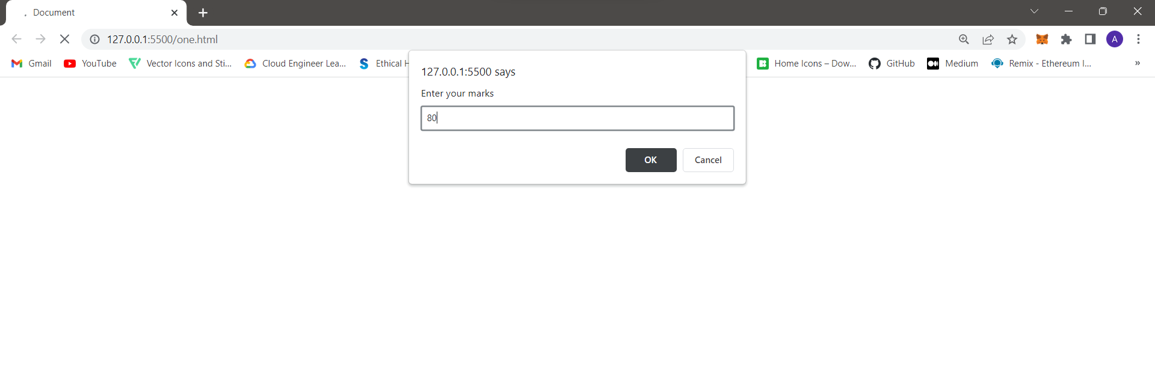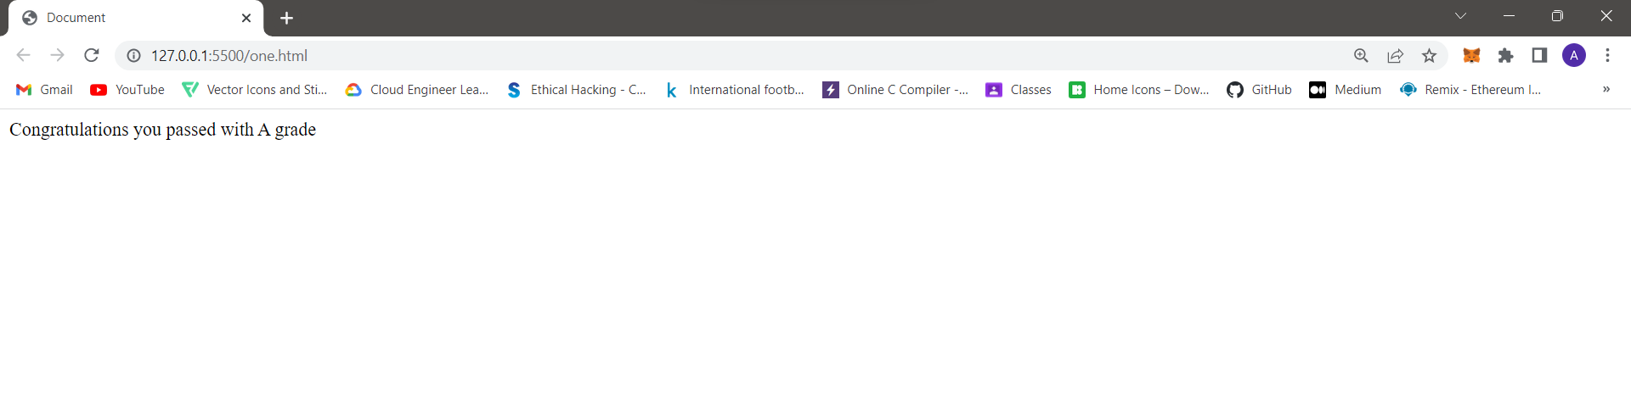



Q2)

<!DOCTYPE html>

<html lang="en">

<head>

    <meta charset="UTF-8">

    <meta http-equiv="X-UA-Compatible" content="IE=edge">

    <meta name="viewport" content="width=device-width, initial-scale=1.0">

    <title>Document</title>

</head>

<body>

    <script>para=prompt("Enter your paragrpagh");

        vowels=["a","e","i","o","u"];

        function countvowel(para)

        {

         let   count=0;

         for(let i of  para.toLowerCase())

         {

            if(vowels.includes(i))

            {

                count++;

            }

         }

        return count;

        }

        document.write("No of vowels in the given paragraph is "+countvowel(para));

        </script>

</body>

</html>

Output:

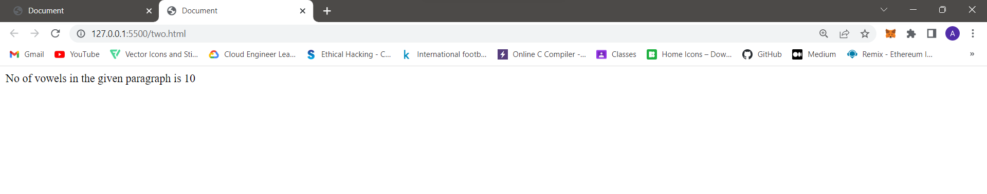

Q3)

<!DOCTYPE html>

<html lang="en">

<head>

    <meta charset="UTF-8">

    <meta http-equiv="X-UA-Compatible" content="IE=edge">

    <meta name="viewport" content="width=device-width, initial-scale=1.0">

    <title>Document</title>

</head>

<body>

    <script >

        let num=parseInt(prompt("Enter number"));

document.write("Orignal number is "+num);

document.write("<br>");

function reverse(num)

{

    res=0;

    while(num!=0)

    {

        n=num%10;

        res=res*10+n;

        num=Math.floor(num/10);

    }

return res;

}

function palindrome(num)

{

    if(num==reverse())

    {

        document.write("Number is palindrome");

    }

    else{

        document.write("Number is not palindrome");

    }

}

palindrome(num);

    </script>

</body>

</html>

Output:

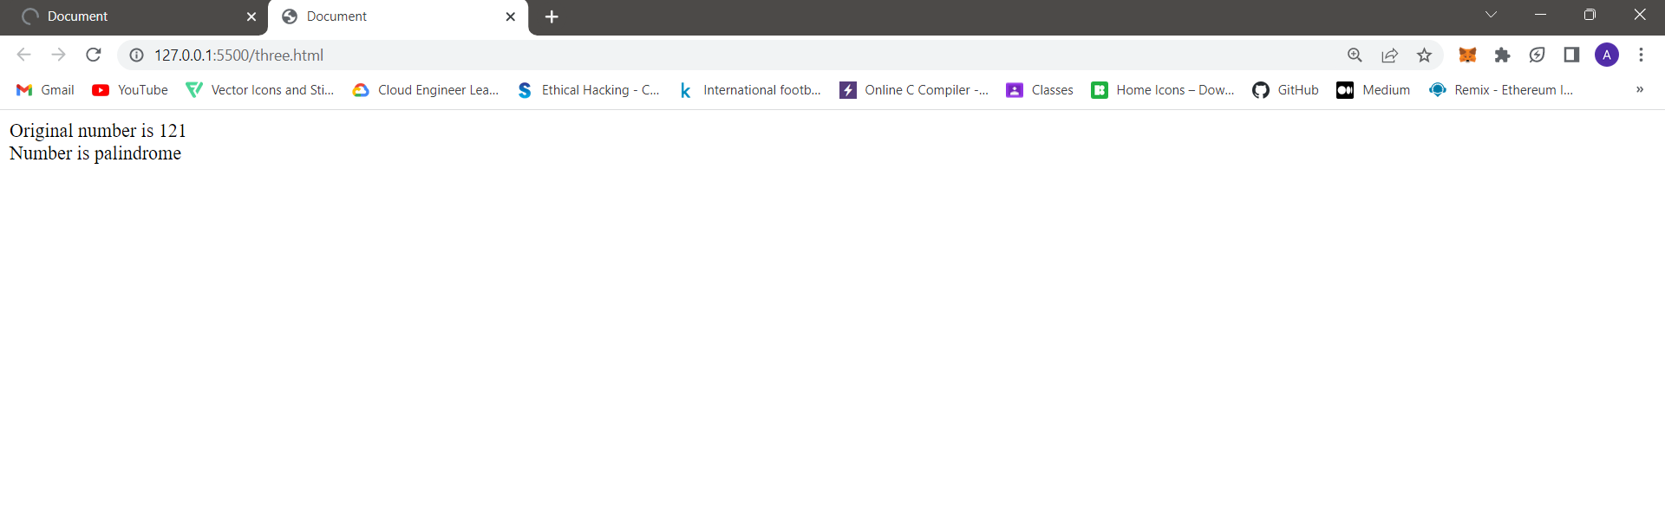

Q4)

<!DOCTYPE html>

<html lang="en">

<head>

    <meta charset="UTF-8">

    <meta http-equiv="X-UA-Compatible" content="IE=edge">

    <meta name="viewport" content="width=device-width, initial-scale=1.0">

    <title>Document</title>

</head>

<body>

    <script>

        const arr=['#'];

for(let i=0;i<4;i++){

   arr.push(prompt("Enter the number : "));

}

arr.splice(0,1);

const mySet = new Set(arr);

const arr1 = [...mySet]

document.write(arr1);

    </script>

</body>

</html>

Input:1,2,2,1

Output:



Q5)

<!DOCTYPE html>

<html lang="en">

<head>

    <meta charset="UTF-8">

    <meta http-equiv="X-UA-Compatible" content="IE=edge">

    <meta name="viewport" content="width=device-width, initial-scale=1.0">

    <title>Document</title>

</head>

<body>

    <script >class Employee

        {

        constructor(name,id,salary,exp)

        {

                   this.name=name;

                   this.id=id;

                   this.salary=salary;

                   this.exp=exp;

        }

        addIncrement(){

        if(this.exp>5){

           this.salary += (this.salary * 0.2);

        document.write("Incremented Salary is "+this.salary);

        document.write  ("\n");

        }

        else{

           this.salary += (this.salary * 0.15);

           document.write("Incremented Salary is "+this.salary);

           document.write("\n");

        }

        }

        }

        let emp=[3];

        emp[0]=new Employee("Prerna",127,90000,7);

        emp[0].addIncrement();

        document.write("<br>")

        emp[1]=new Employee("Pa",17,900560,3);

        emp[1].addIncrement();

        document.write("<br>")

        emp[2]=new Employee("Pre",7,90120,12);

        emp[2].addIncrement();</script>

</body>

</html>

Output:

